Using the Student Portal to review and update 2021-22 Course Requests!
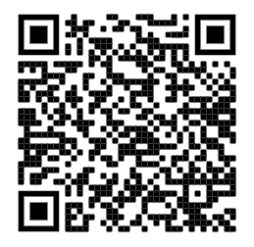
Current LRHS Students Grade 9, 10, and 11
To get into your student portal:
- Use the QR code on the right
- Or go to https://baltimore.focusschoolsoftware.com/focus/
- Select: Sign in with Microsoft but do not enter your username and password yet!
- When the next screen pops up, enter your BCPS username@bcps.org and password.
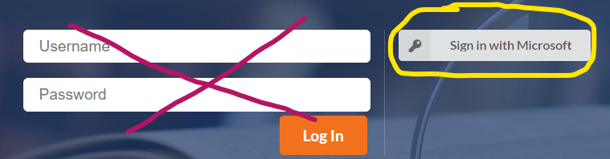

The Student Portal is where you can review what core academic courses you were recommended for and what elective courses you requested for the 2021-22 school year. It’s time to do this now!
- Log in as stated above.
- In the upper righthand corner, make sure the year selected is 2021-22 (You will know you are in year 21/22 because the border of the portal will be RED.)
- On the left-hand side click class requests and your request should show. The core courses and courses that are electives will show a priority of a blank space or a 1 to communicate your top choices. A priority of 2,3,4 would be alternates if your top elective picks don’t fit. If you haven’t selected alternates, you should do so in the survey.
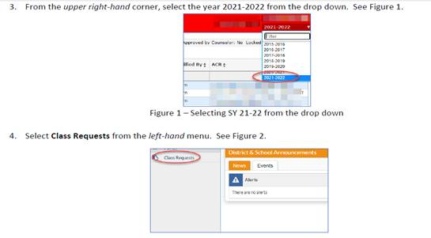

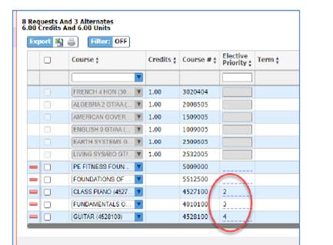

- To adjust or update a course request for an elective class, use the QR code below to access the Course Request Change Survey.
- Changes to core subjects must be approved by your teacher or the Department chair. Core subjects include English, Social Studies, Math, and Science.
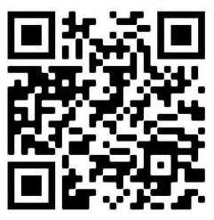
Who is your school counselor?
Use this QR code to update your current course requests for next year.

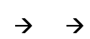
Last name A-G -- Ms. Jessica Moody
Last name H-O -- Ms. Tracey Johnson
Last name P-Z -- Ms. Sarah Miller

